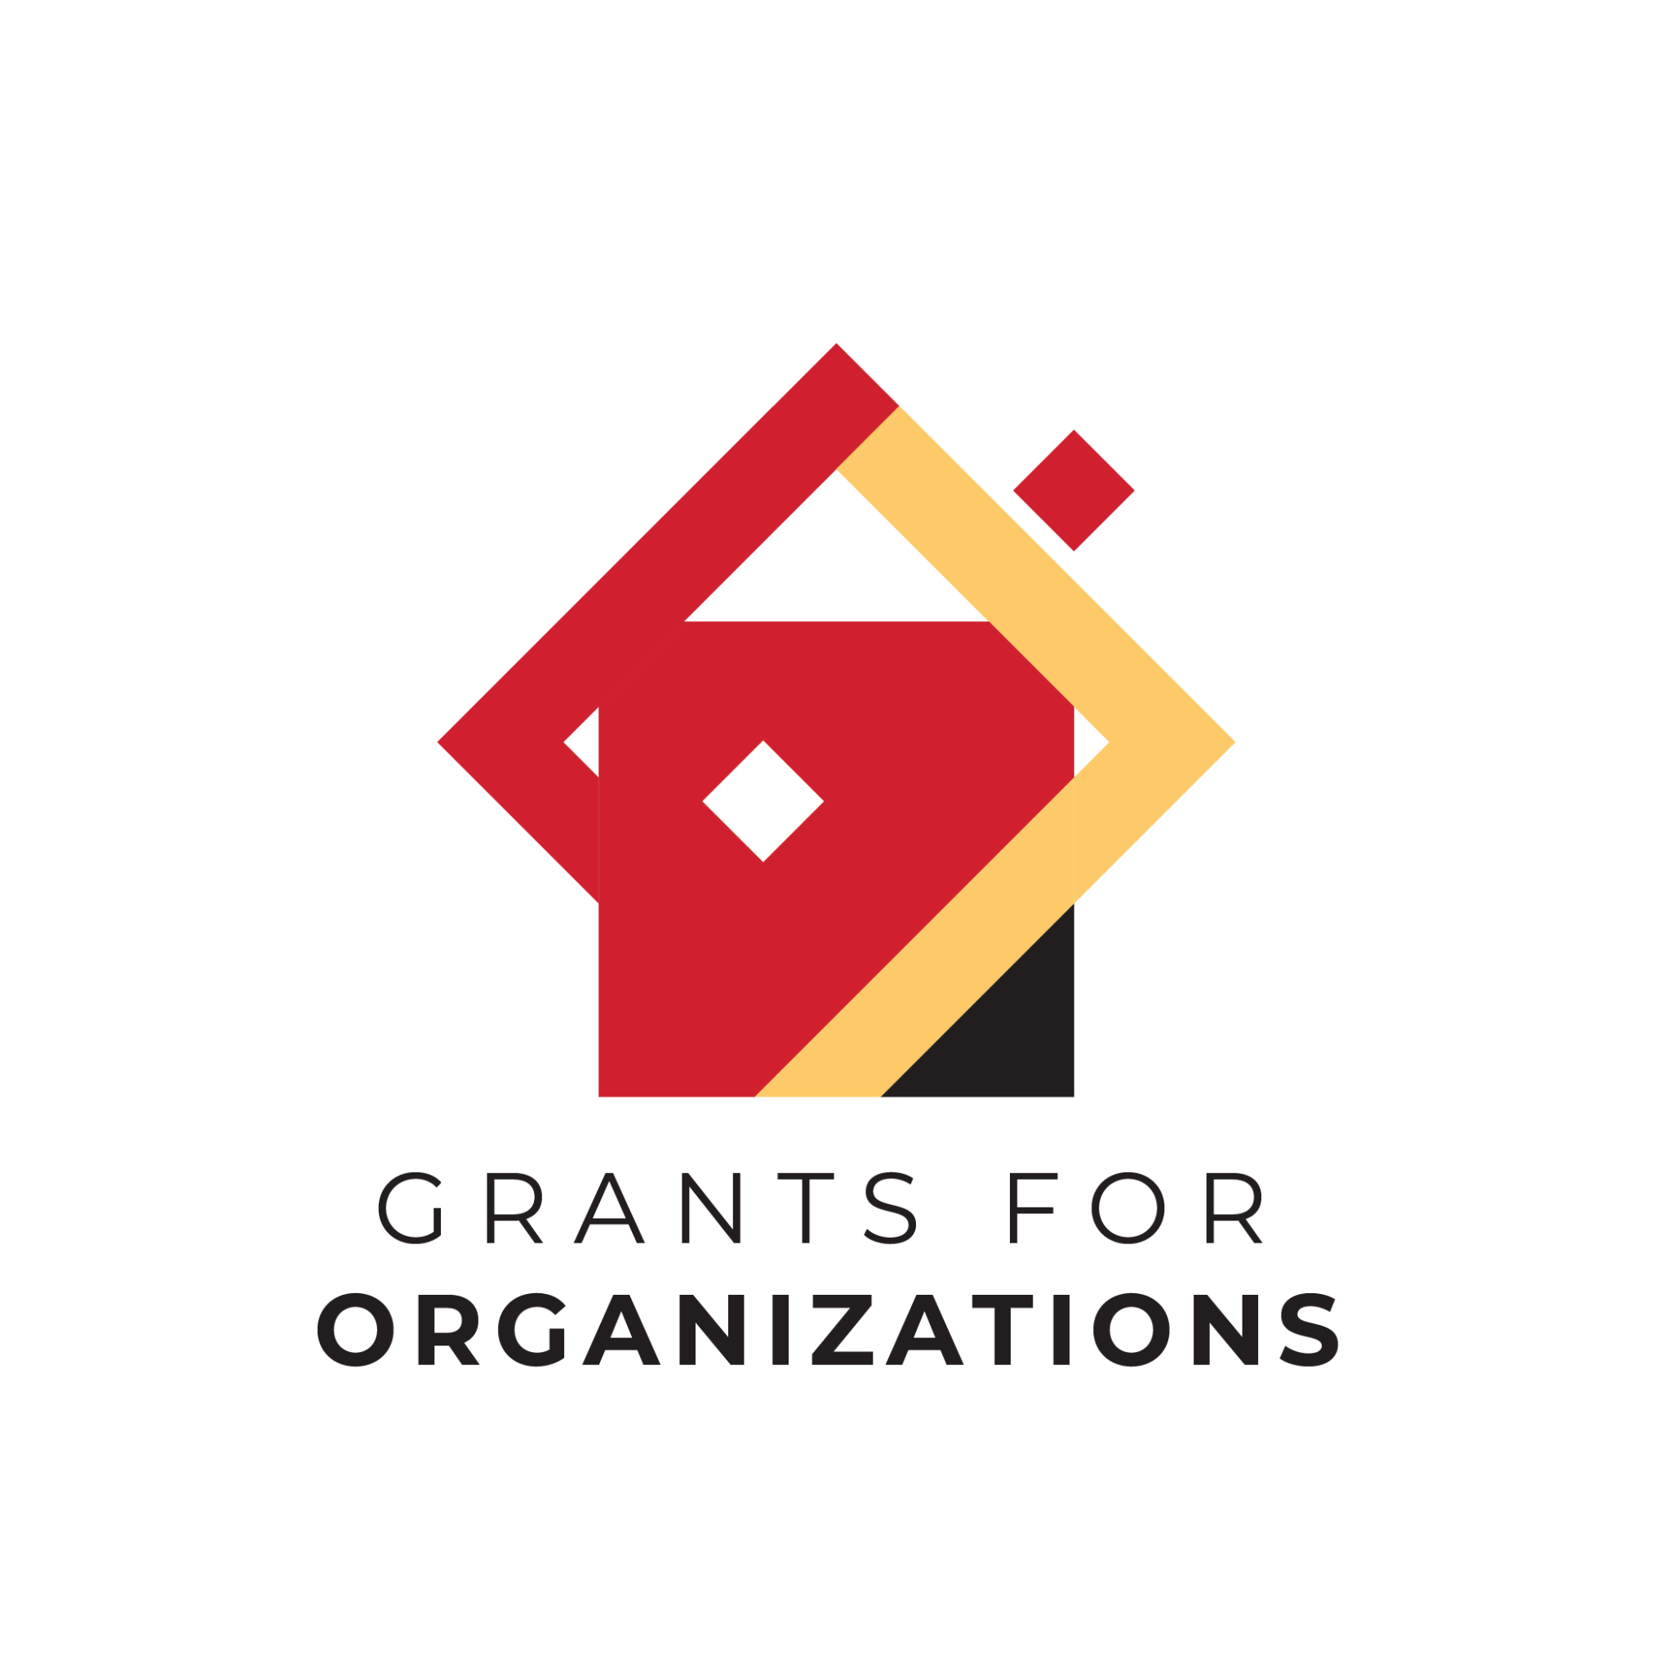

| **FY 2026 Grants for Organizations (GFO)**  **“Off Year” Application**  **Deadline - December 15, 2024**  Narrative Questions, Financial Information + Attachments |
| --- |

At the beginning of the Program Details section of the application, your organization will be asked two general questions before moving into the Narrative Section, and other tabs of the application.

**Are you applying on behalf of an Arts Organization or Arts Program?**

* Select "Arts Organization" if your non-profit organization's mission/purpose is producing or presenting the arts through public programs or services.
* Select "Arts Program" if your non-profit organization's primary mission/purpose is other than producing or presenting the arts, but provides ongoing arts programming/activities through public programs.
* *More info can be found in the FY26 GFO Grant Guidelines. If you are uncertain, contact your Program Director.*

**Select the primary artistic discipline for your organization’s application.**

Please select the artistic discipline (from the dropdown menu) that aligns most closely with your arts organization/program's activities. You should already have this assignment, but if you are uncertain, contact your Program Director.

| **NARRATIVE QUESTIONS** |
| --- |

| **1. Has your mission/vision/goals/values significantly changed since your last application?** *(Not Scored)* |
| --- |

| *1. Answer: YES/NO:*   * Yes: Please explain the changes to your mission/vision/goals/values. In your response, please address what the changes are, the reasoning behind the changes, and how those changes have impacted the organization and its programming. * No: no narrative |
| --- |

| **2. Has your organization’s programming significantly changed since your last application? Significant changes would include adding or removing a program from the Activities Chart included in your last On Year application.** *(Not Scored)* |
| --- |

| *2. Answer: YES/NO:*   * Yes: Please explain the changes in your organization’s programming. In your response, please address what the changes are, the reasoning behind the changes, and how those changes have impacted the organization. * No: no narrative |
| --- |

| **3. Have there been any additional challenges or updates (changes in operations, staff, leadership, etc) since your last application?** *(Not Scored)* |
| --- |

| *3. Answer: YES/NO:*   * Yes: Please briefly explain the challenges and/or updates, the steps the organization has taken to address these challenges and/or updates, and any additional details to why these activities occurred. * No: no narrative |
| --- |

| **OTHER REQUIRED SECTIONS** |
| --- |

| * **Financial Information Section**   + Complete Financial Table: Enter the income and expenses for your arts organization’s or arts program’s most recently completed Fiscal Year (FY24 or CY23)     - Resource: download a spreadsheet template from the website or request from the Program Director to use as a guide.     - Information entered in the Financial Table should reflect the Financial Statement in the attachment section (see below).     - *Arts Programs: This information should reflect your arts-based income and expenses, (rather than a full organizational statement). * **Attachments Section**   + IRS Letter of Determination   + Completed and Signed Form w-9   + Financial Statement(s): Attach a financial statement (such as a P&L or audit, as described below) that reflects the numbers submitted in the Financial Table on the previous tab (Financial Information Tab).     - For applicants with Allowable Income under $750,000:       * A submission of the organization’s most recently completed fiscal or calendar year Financial Statement, signed by a professional accountant or the organization’s fiscal officer.     - For applicants with Allowable Income over $750,000:       * A submission of the organization’s most recently completed fiscal or calendar year Independent External Audit, prepared by a CPA firm.   + *Arts Programs Financial Statement (required for Arts Programs only in addition to full organization financials): Please attach a Financial Statement from the most recently completed fiscal or calendar year that is specifically for the Arts Program only (this should include the income/expenses directly connected to your arts programming only, not your full organizational financials) |
| --- |